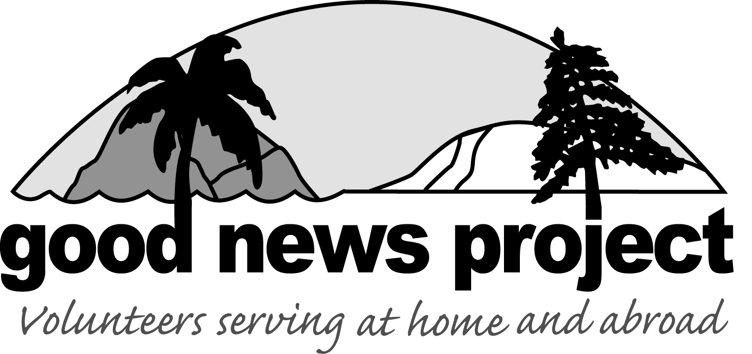

Working with Vulnerable Populations

As Good News Project volunteers, our first thoughts are usually about helping the people that we come into contact with to the best of our ability. We most likely aren’t thinking of ourselves as a potential threat to vulnerable populations. That being said, it is something that is worth taking a moment to educate ourselves about.

What is a vulnerable population? Vulnerable populations include any population with which you are working that have some kind of power differential. This can be the economically disadvantaged, racial and ethnic minorities, women, children, the elderly, the homeless, those with chronic health conditions including mental illness, those in rural communities, and those with inadequate education, just to name a few.

We don’t often think of ourselves as having an ascribed power differential, but we do. Most of us come from the United States or Canada, we have a much higher socioeconomic status than the people we are working with, some of us have attributed power due to gender, race, or age, and we are working with an organization that has a great reputation which also adds to our perceived status.

The meaning of all of this is fairly simple. When we are working on the island of our choice, we need to be aware of our behaviors at all times. At no time should any of our actions be able to be perceived as meant to take advantage of anyone with whom we have contact. This can be the people we are serving, others on the islands, or fellow volunteers. As an additional safeguard, you should try to never be alone with someone in a position of vulnerability and should try to maintain two-deep leadership if at all possible (this means try to stay with a GNP buddy). You should never be alone with a child, a person of opposite gender, or other vulnerable individual as this creates the potential to put both them and you at risk.

Unfortunately, we live in a world where it is becoming more and more important to protect not only the populations that we work with but also the volunteers we send. We would never want the actions of our volunteers to be misconstrued and cause the potential for harmful allegations. For everyone’s safety and well-being, we ask that you be cognizant of all of your actions and the potential for harm as you travel and work with vulnerable populations. Our goal is for your trip to be fun, safe, and a positive experience for everyone.

1106 Fifth Street / Wausau, WI 54403 / Phone: 715-843-5985 / FAX: 715-843-5298 / www.goodnewswi.com

